**Project 1 Report**

**Ques 2:**

**No of Variables:** The Merged dataset has 89 variables in total.

**Types**: There are 43 float variables, 30 integer variables and 16 object(String) variables.

**Missing variables:** There are two variables with missing/NaN values namely **No Preference Party** and **Uncommitted Party**

**Dealing with Missing values:** We **drop** the variables consisting of missing values using **dropna** function.

**Ques 6:**

Mean Democratic county population: 185786.7245

Mean Republican county population: 78017.0336

**Democratic county population is higher.**

**Hypotheses Test statistics: (u1 = u2) VS (u1>u2)**

* **Test statistic: 4.5427**
* **P-Value: 3.32 e-06 (right tailed)**

Clearly p-value < 0.05 hence there is **statistically significant** evidence that the mean democratic county population is greater then the mean of republic county population.

**Ques 7:**

Mean democratic county median house income: 45643.871

Mean republic county median house income: 45265.621

Mean democratic county house income is slightly greater.

**Hypotheses Test Statistics: (u1=u2) VS (u1 != u2)**

* **Test Statistic: 0.5414**
* **P-Value: 0.5883**

Clearly p-value > 0.05 and hence **there is no statistically significant evidence** to prove the median house incomes were different.

**Ques 8:**

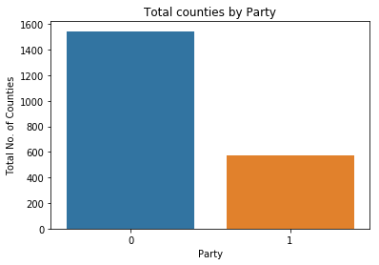

Clearly there were significantly more republic counties than democratic counties in 2014 midterm election

**Party Vs Population**

**statistic=4.542, p-value=3.312e-06**

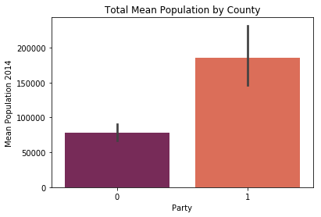

Clearly the **mean population of Democratic Counties is higher** that Republic counties

**Party Vs Age**

**18-65 Years Vs 65 and above (legal age to vote)**

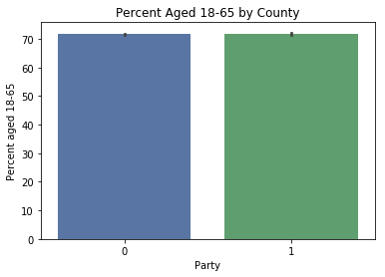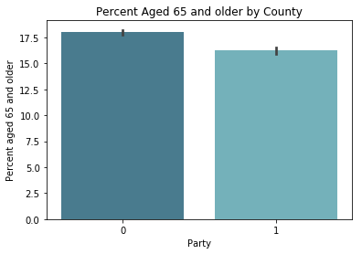

There were **close to equal percentage of people** in both Republic and Democratic counties with the legal right to vote

**Party Vs Degree**

**(High School) VS (Bachelor and higher)**

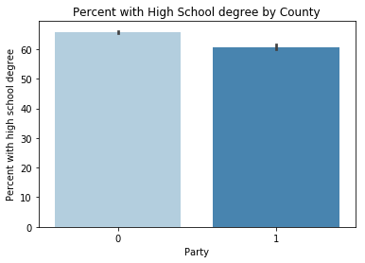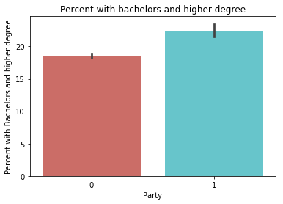

Clearly There **wasn’t any significant difference** in the education levels of people in both counties.

**Party Vs Sex**

**Male Vs Female**

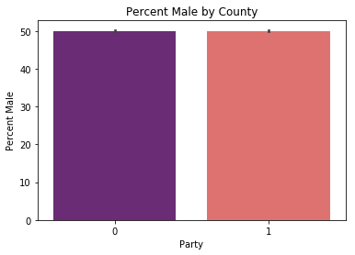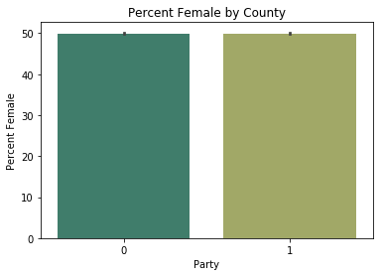

Clearly there is **no difference** in the percentage of male and female population in both counties

**Party Vs Race and Ethnicity**

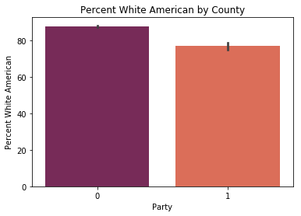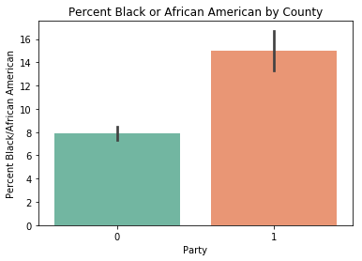

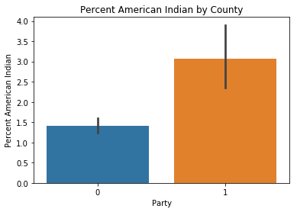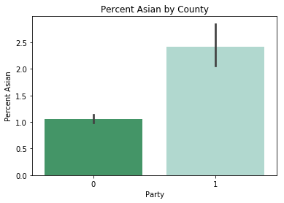

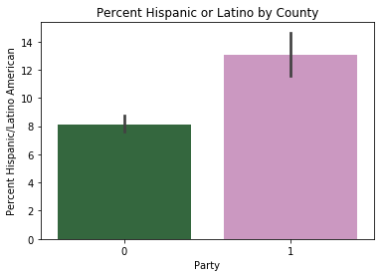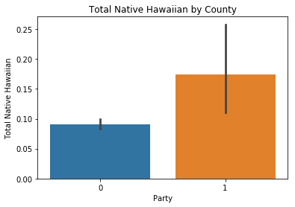

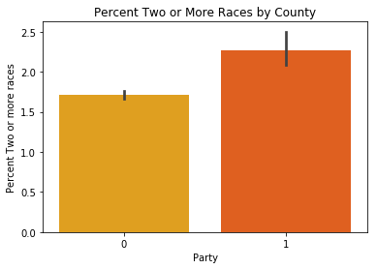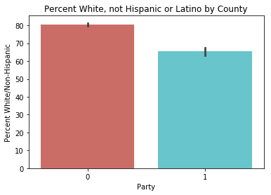

Considering all the races and ethnicities in different counties the only significant differences in the percentage were found in the **White**(More in **Republican** Counties), **Black**(More in **Democratic** Counties), **Hispanic or Latino**(More in **Democratic** Counties), **White non-Hispanic**(more in **Republican** Counties)

**Ques 9:**

Based on the plots above the variables that show statistical difference in determining the counties being Democratic or Republic are:

* **Race:** Clearly higher percentage of **White Americans** were found in **Republican** Counties while higher percentage of **Black and Hispanic or Latino** were found in **Democratic** Counties.
* **Population:** Clearly the **Mean Democratic County population was significantly higher** than the Mean Republic County Population.

**Ques 10:**

